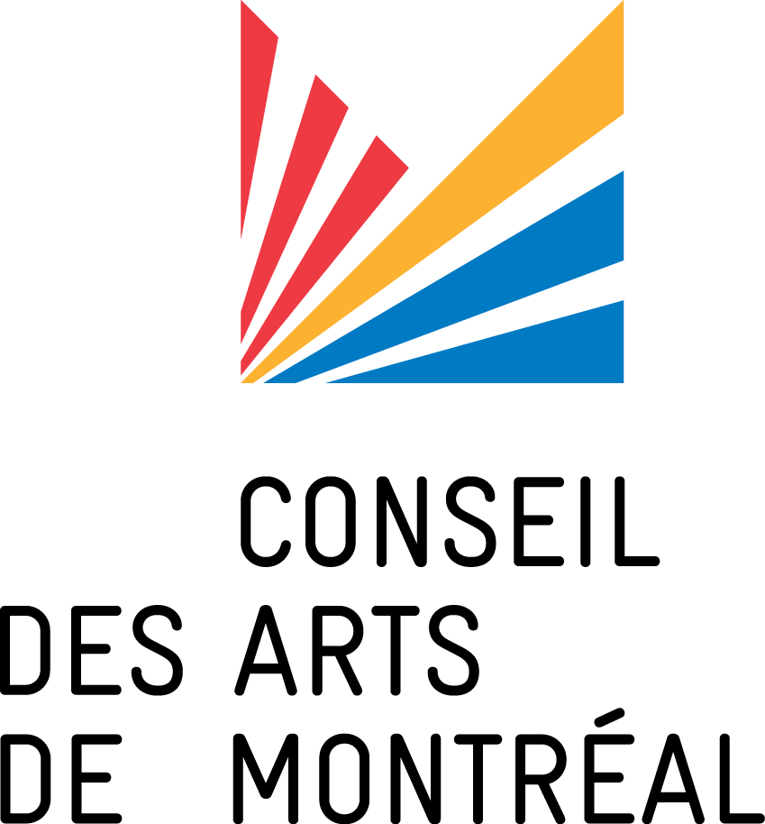
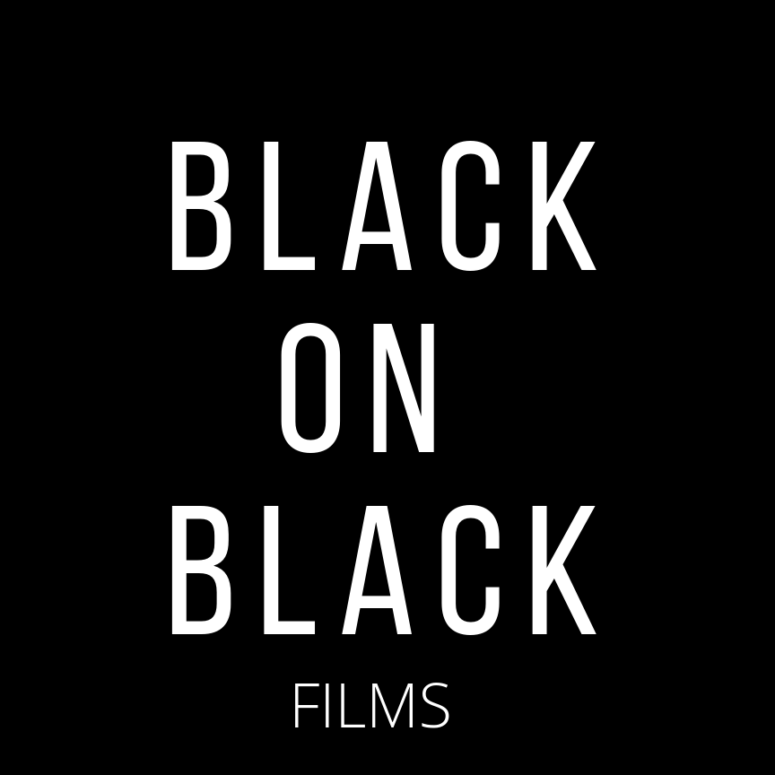

CALL FOR NOMINATIONS:
Film REsidency « Je me vois à l’écran »
Screenwriting residency for emerging film artists from Afro-descendant
communities in Montreal
Deadline: October 18th 2019 – 11.59 pm
The Conseil des Arts de Montréal is partnering with Black on Black Films to offer, for a first edition, a screenwriting residency - « Je me vois à l’écran ». This pilot project, aimed at emerging filmmakers from Afro-descendent communities in Montreal, wishes to support their artistic practice and professional development as well as their access to the film industry.
During the 20 weeks of the program, the creative laboratory will consist of writing and directing workshops, personalized and group accompaniment. This residency will allow four Afro-descendant artists at the beginning of their career to explore their unique voices within a group of peers. Professionals filmmakers will accompany them throughout the writing lab.
At the end of the residency, the artists will have completed the writing of a short fiction film that reflects their concerns and which will enrich a body of Quebec film from a perspective that has not been fully explored to date: that of the Afro-descendant filmmakers. They will also receive a $1000 bursary.
For more information and to apply, consult these following documents:
Presentation of the program
Application Form
For more Information:
Black on Black Films
Stefan Verna - Co-founder
info@blackonblackfilms.org
(514) 802-2841
An initiative of Black on Black films with collaboration
of the Montreal Arts Council

