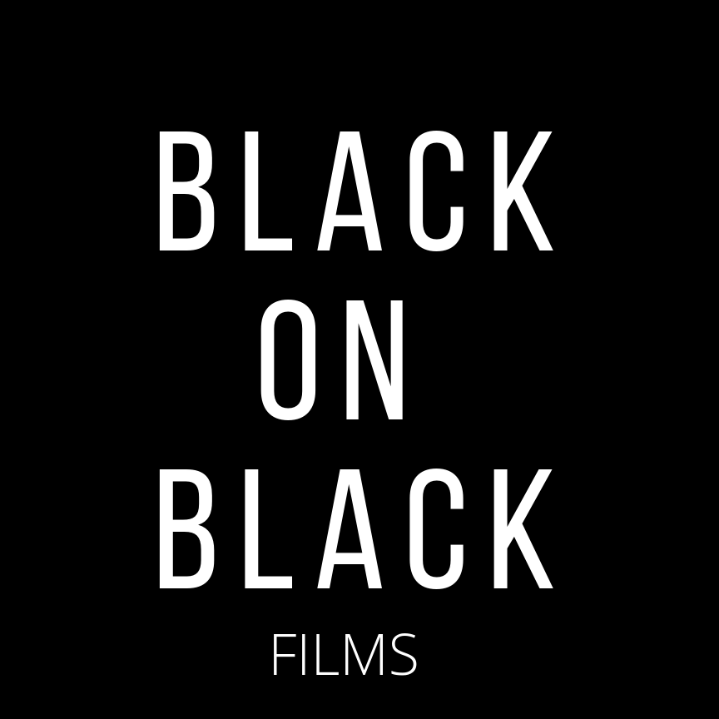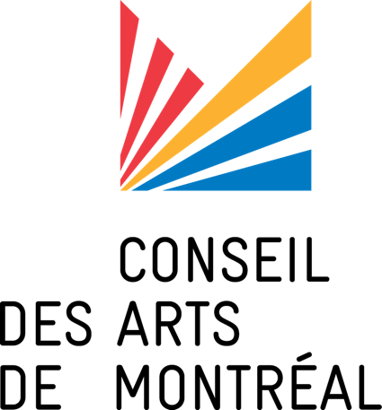

Second Edition
FILM RESIDENCY in SCRIPTWRITING
« JE ME VOIS À L’ÉCRAN »

For emerging film artists from Afro-descendant communities in Montreal

Presentation of Program 2020-2021

WHAT SHOULD I KNOW ABOUT THIS PROGRAM?

  - WHO IS THIS PROGRAM FOR?
Emerging film artists from Afro-descendant communities in Montreal.

WHAT TYPE OF PROJECTS ARE ELIGIBLE?
Screenwriting projects for a short fiction film.

HOW MANY APPLICATIONS WILL BE ACCEPTED?
Four (4) applications will be retained.

WHAT TYPE OF ASSISTANCE IS PROVIDED?
The selected artists will participate in a creative laboratory during which they will complete the writing of a short fiction film. Throughout the 20 weeks of the program, they will be accompanied by professionals and will have access to various tools. In addition, a $ 1000 bursary will be awarded.

WHAT IS THE DEADLINE?

November 22, 2020 – Before 11:59 pm.

  - WHAT ARE THE OBJECTIVES OF THE PROGRAM?
Black on Black Films and the Montreal Arts Council pursue the following objectives with this program:

    - Support the artistic vitality and professional development of artists from Afro- descendant communities at the beginning of their career.
    - Promote their access to and increase the presence of the film industry and industries.
    - Supporting the integration of the societal and cultural peculiarities of Afro- descendant communities in the development of fictional narratives rooted in contemporary Montreal reality.

WHAT ARE THE CONDITIONS FOR SUBMITTING AN APPLICATION?

  - GENERAL CONDITIONS OF ELIGIBILITY

Status and Conditions
    - Being a professional emerging artist from an Afro-descendant community.
    - Be a Canadian citizen or Canadian permanent resident at the deadline date.
    - To be a resident of the territory of the island of Montreal.

Professional Artist
Is considered in this program as a professional artist, whether self-taught or has obtained an academic training, an artist who has acquired the experience and knowledge necessary for the development of his personal practice, while being recognized as such by his peers (artists of the same artistic tradition).

He creates, interprets or publishes works publicly, devotes himself mainly to the practice of his art and should receive remuneration for the works he produces.

Emerging Artist

In this program, an emerging artist is considered to be an artist who has a minimum of professional experience without having already integrated the usual financing circuits. He/she must have completed at least one scripting or production project. The artist must be 18 years of age or older by the application deadline.

SPECIFIC CONDITIONS OF ELIGIBILITY

    - Have a short film project idea.
    - Be available for a period of 20 weeks (part-time - time to be defined with the candidate and the mentor).

WHO CANNOT APPLY AND WHY?

3.1 INADMISSIBILITY OF INDIVIDUALS
Artists who do not meet the general and specific conditions of eligibility.

INADMISSIBILITY OF PROJECTS
    - Projects already scripted.
    - Projects of essentially promotional nature.

INADMISSIBILITY OF APPLICATIONS
    - Incomplete applications
    - Applications filed by an organization
    - Requests received after the filing deadline.

WHAT ARE THE SPECIAL FEATURES OF THE PROGRAM?

  - IN WHAT LANGUAGE SHOULD I SUBMIT?
Writing projects in French or English are accepted.

WHAT IS THE DURATION OF RESIDENCY?
The residency program will be carried out over a period of 20 weeks (part-time). At the end of the program, a public reading of the scripts will be organized with a partner from the film industry.

WHAT IS THE NATURE OF SUPPORT?

    - Services offered (120 hours)
      - Writing and scriptwriting workshops
      - Reading Committees
      - Intro to Directing workshops
      - Networking techniques and participation in professional meetings
      - Search for funding and writing requests
      - Reading session of scenarios with actors
At the end of the program, the candidates will have completed the script of a short film which they will retain the rights to and which they can submit to institutions for financing.

Financial Assistance

A $1000 Creative Support Grant will be available to each artist upon completion of the program. A first installment of $ 500 will be paid to the candidate for the delivery of a first scenario version and a second installment of $ 500 will be paid upon delivery of the final version of the script at the end of the program.

HOW ARE APPLICATIONS EVALUATED?

Applications will be judged by a jury composed mostly of members of the Black on Black Films collective and a representative of the Conseil des arts de Montréal.

All projects will be evaluated on merit and the selection will take into consideration the comparative value of the projects.

WHAT ARE THE EVALUATION CRITERIA?
The evaluation committee will consider the objectives of the program and the following criteria:

- Artistic quality of the script
- Artistic quality and originality of previous work
- Impact on the integration of the artist in the Montréal arts scene
- Project feasibility.

The evaluation committee will pay particular attention to artists from outlying areas of Montreal, as well as projects that are part of the creation of an Afro-centric vision of Quebec cinema.

WHO EVALUATES AND HOW ARE DECISIONS TAKEN?

    - What is the procedure?
      - Receipt and verification of eligibility
      - Selection of 8 finalists by jury members, composed of professional members of Black on Black Films and a representative of the Conseil des arts de Montréal.
      - The finalists will present their project in person to the jury members for the choice of the 4 laureates.
      - Communication with the laureates who must reiterate their availability.

HOW TO SUBMIT MY APPLICATION?

  - WHAT DOCUMENTS SHOULD I SUBMIT?
- The completed form
- A letter of intention explaining why you want to participate in this program
- An excerpt from an earlier script, written in French or English, 4 pages max (PDF format) OR a video project (video link)
- A synopsis of the short fiction film project, 1-page max (PDF format)
- The CV of the artist.

Only the required documents will be sent to the members of the jury.

6.2 WHAT IS THE SUGGESTED FORMAT FOR SENDING THE FILE?

All documents (PDF) must be bundled into a single zip file and sent via WeTransfer, Google Drive or other file transfer tool.

Applications must be emailed only to the following email address: jmvae@blackonblackfilms.org

HOW WILL THE BURSARY BE GIVEN?

  - WHAT ARE THE TERMS OF THE BURSARY?

A first installment of $500 will be paid to the candidate for the delivery of a first version of the script and a second installment of $500 will be paid upon submission of the final version of the script and the participation report at the end of the program.

WHAT ARE MY OBLIGATIONS?

  - REPORTS
    - What ?
The artist will present a participation report, the format of which will be defined by Black on Black Films.

When ?
No later than 3 weeks after the end of the 20-week program.

How ?
The program Coordinator will send the participant the template of the report to be completed by email.

OTHER OBLIGATIONS

    - Proof on commitment
An agreement will be signed with the selected artists and Black on Black Films.

Notice
The artist agrees to:
      - Write your project as planned
      - Advise as soon as possible of his / her inability to complete the writing project and related activities in a timely manner.

WHEN CAN I SUBMIT MY APPLICATION & WHEN WILL I HAVE MY ANSWER?

  - WHAT IS THE DELAY FOR THE FINAL DECISION?
Between the filing deadline and the processing of files, a period of 4 weeks is required for the processing of applications. However, finalists selected to present their project in person to the selection committee will be notified the week of December 7th 2020.

HOW WILL I BE NOTIFIED OF THE DECISION ?
The artist will be notified of the decision by email. No decision will be given over the phone.

WHO CAN I CONTACT TO GET INFORMATION ON MY APPLICATION?
Marie Ka et Mylène Augustin, Project Coordinators
jmvae@blackonblackfilms.org

HOW CAN I GET MORE INFORMATION ?

  - ON BLACK ON BLACK FILMS FACEBOOK PAGE

  - FROM THE COORDINATORS OF THE PROJECT
For Black on Black Films
Marie Ka et Mylène Augustin
jmvae@blackonblackfilms.org

